MYSQL
ASSIGNMENT-1
Trade: CSA Date:01-09-2026
- Write a MySQL query to create a simple table Countries including columns country_id, country_name and region_id. Make the country_id column as a primary key.
- Write the command to show the structure of the above table.
- Write the query to insert 5 rows in the above table. Also write the query to display the whole table.
- Create the table customer as per the following structure.
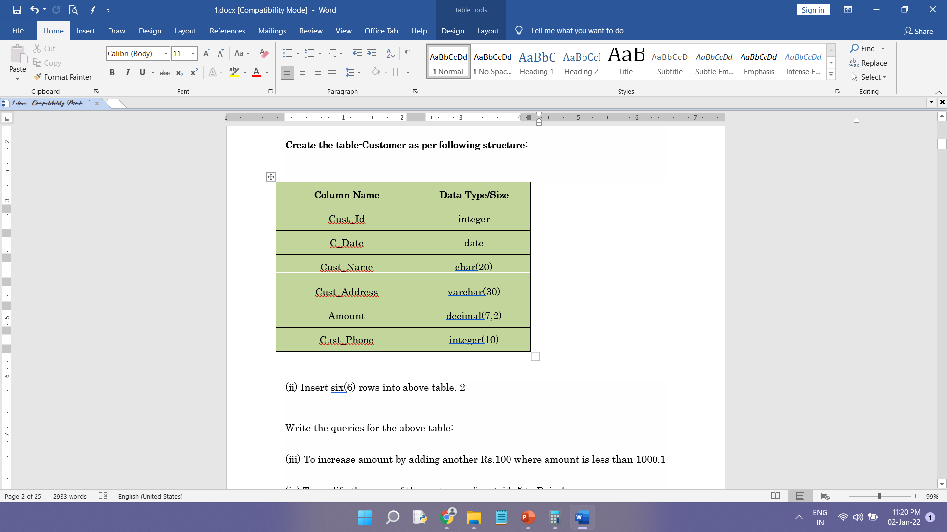

- Observe the table below and write the sql queries for the following.
- Update the CustomerName to Nitin where the Age is 22.
- Make the CustomerId column as primary key.
- Display the distinct age from the table.
- Delete the customer Nishant from the table.
- Update the country name of Aman to India.
Table: Customer
